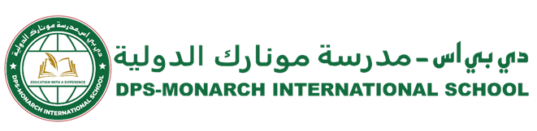

DPS-Monarch/CIR/SCY/2025-26/339 Date: 05.02.2026
From Principal’s desk….
Dear Parents,
Greetings from DPS Monarch International School!
We would like to inform you of the following important updates regarding student dispersal timings and school operations in view of upcoming KG Annual Day celebration and Qatar National Sports Day celebrations for staff :
1. KG Annual Day on Monday, February 09, 2026:
- Early dispersal for students from Grade 1 to Grade 12 at 11:50 a.m.
- School buses will depart from school at 12:10 p.m.
2. School Closure on Tuesday, February 10, 2026 :
In observance of Qatar National Sports Day, the school will remain closed on Tuesday, February 10, 2026 for all students and staff.
3. Qatar National Sports Day celebrations for staff on Wednesday, February 11, 2026 :
- Student Dispersal Time: 01:00 p.m.
- School Bus Departure: 01:10 p.m.
- The school offices will remain closed after 01:00 p.m.
Parents are requested to take note of the above timings and plan accordingly.
We appreciate your cooperation and continued support.


Warm regards,

Meenal Bakshi
Principal

Our Motto
Education with a difference

Our Vision
DPS Monarch International School will deliver learning excellence that is child-centric, value-based, and technology-driven.

Our Mission
DPS Monarch International School will ensure that students add value to their community and make the world a better place to live.

