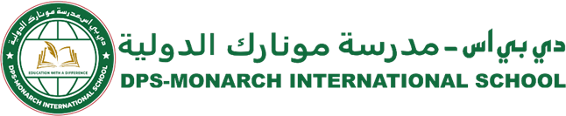

DPS-Monarch/CIR/SCY/2025-26/340 Date: 12.02.2026
From Principal’s desk….
Dear Parents,
Greetings from DPS Monarch International School!

We are pleased to announce the appointment of Ms. Sonal Nayak as the new Hindi Teacher and Class Teacher of Grade 4 D, effective immediately. Ms. Sonal is a dedicated and enthusiastic educator with a strong background in education. She brings with her a passion for teaching and a commitment to nurturing students academically as well as personally. We are confident that she will ensure a smooth transition and continue to guide the students with care and dedication.

For any queries or concerns regarding your child, you may reach out to her at:
Email: Sonalnayak@misdoha.com

We seek your continued support and cooperation during this transition and remain committed to providing a positive and enriching learning environment for all our students.

Warm regards,

Meenal Bakshi Principal

Our Motto
Education with a difference

Our Vision
DPS Monarch International School will deliver learning excellence that is child-centric, value-based, and technology- driven.

Our Mission
DPS Monarch International School will ensure that students add value to their community and make the world a better place to live.

