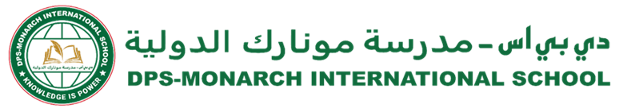

**DPS-Monarch/CIR/SCY/2024-25/220 Date: 16.02.2025**

*From Principal’s desk….*

Dear Parents,

Greetings !

Our long-standing partnership with FIITJEE (India) goes back since inception (2019) and is one of the top-most coaching programs amongst Indian schools in Qatar. Through this partnership we are able to guide and mentor students in science and mathematics and hence prepare them for various competitive examinations. Our shared mission has always been to nurture young minds and empower them to achieve their fullest potential.

FIITJEE faculty, many of whom are working with us since 2019, share the school’s idea of fostering student success. They are deeply committed to supporting every child in achieving outstanding results and qualifying for various competitive examinations like JEE, NEET along with CBSE Board Results and School examinations. Their commitment and belief in the transformative power of education have been, and always will be, at the core of what we do.

Their long-standing team of educators has consistently delivered high-quality education, working closely with students to help them succeed. Through their tireless efforts we have seen remarkable results with our students achieving top positions not only in CBSE Board Examinations but also securing admissions to some of the best institutions globally.

In collaboration with FIITJEE, we have introduced student enrichment activities, workshops and career counselling sessions that have undoubtedly benefited our students.

Considering our long-term partnership with FIITJEE (India), Monarch International School reassures all parents that the partnership and the staff members executing this program in Qatar have no bearing on any events happening with FIITJEE in India.

Thank you for your unwavering support, trust and partnership. Together, we stay committed to shape a bright future for the students at our school.

Warm regards,

_______________________

**Meenal Bakshi**

**School Principal**

**Our Motto**

**Education with a difference**

**Our Vision**

**DPS Monarch International School will deliver learning excellence that is child-centric, value-based, and technology-driven.**

**Our Mission**

**DPS Monarch International School will ensure that students add value to their community and make the world a better place to live.**